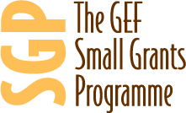
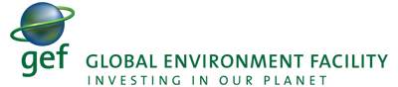
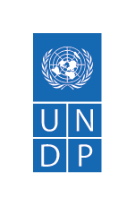

Quarterly Progress Report

Liberia
GEF/UNDP Small Grant Programme

04 Quarter (October-December) Project Progress Report – 2025

[Optional] Insert a picture that effectively communicates tangible results/impact o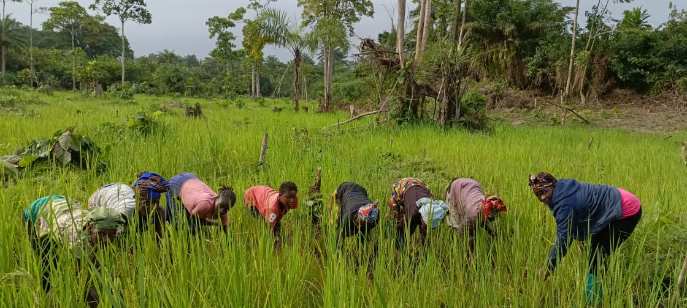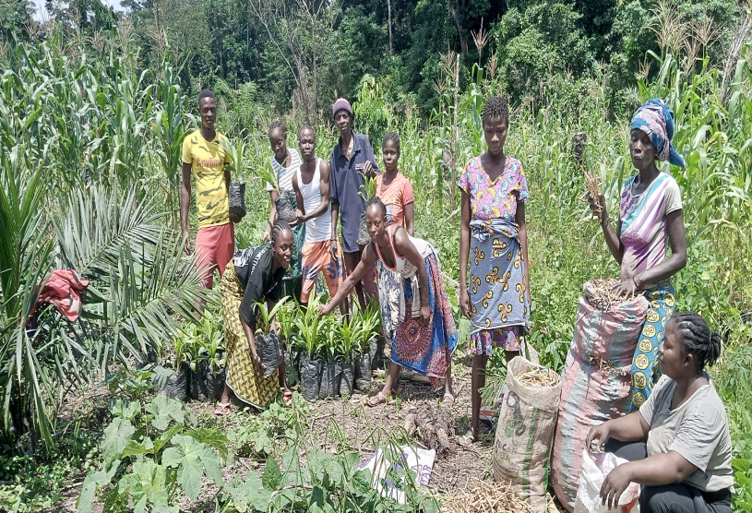f the programme/project.

Reporting Period | 1-October -December 2025
Donor | GEF
Country | Liberia
Project Title | GEF-UNDP/Small Grants Programme
Project ID  (Atlas Award ID)  Outputs  (Atlas Project ID and Description)  Strategic Plan and/or CPD Outcomes | 01004284  1382630  N/A  By 2030, people in and of Liberia, especially children, young persons, women and people with disabilities benefit from an economic model that is founded on synergy among socio-economic and environmental policies and systems, lifted out of poverty and enhancing their access to decent jobs and agri-food systems
Implementing Partner(s) | CBO/CSOs
Project Start Date | 1-January 2025
Project End Date | 31- December 2028
[Year] Annual Work Plan Budget | USD 104
Total resources required
Revenue received | - Donor: GEF 413,924.97 USD  - UNDP Co-fund USD  - Government Co-fund USD  - Total 413,924.97 USD
Unfunded budget | USD 206,075.03
UNDP Contact Person | Aliou M. Dia  UNDP Resident Representative  UNDP Liberia  Email: aliou.dia@undp.org  Tel.: +27 11 603 5095
Table of Content

I. Executive summary 3
II. Background 3
III. Progress Review 4
IV. Project Risks and Issues 8
a. Updated project risks and actions 8
b. Updated project issues and actions 8
V. Lessons Learned 9
VI. Conclusions and Way Forward 10
VII. Financial Status 11
VIII. Annex 12

- Executive summary
Output 3.2 Market based solutions developed to support green entrepreneurship, renewable energy diffusion, and ecosystem-based livelihoods, with attention to gender inclusion.
Output 3.3: Resilience enhanced through improved infrastructure, climate adaptation and mitigation, and benefit-sharing from natural resources. For this fourth quarter, not much has been done as the programme has just transitioned to UNDP for direct implementation. The global budget was set-up in quantum and the Country set up is been workout at the Country level by UNDP. The total funding allocated this year is 413,924.97, 10% of the total funding for the four years. This is under phase Eight of the GEF funding to the SGP for Liberia. To date, we have replaced two National Steering Committee (NSC) members while others who tenures got expired are expected to be replaced in 2026. we have lunched Three grants call for proposals through quantum and the evaluation and selection of grantees has been completed, we are at the grant agreement stage and is expected to pay the grantees before the end of December 2025. For challenges and lesson learned, we have had delay in transitioning to UNDP because there were many issues to understand and factors including the granting modality, the NSC position under the UNDP as the implementing partner, the staff movement to UNDP contract type, the finalization of the SGP Country Programme strategy which is yet to be finalize amongst others. There is a lot of lessons we are still learning but importantly, we are learning by doing and optimistic of pulling through all that to have a successful programme that will be aligned with the programme objectives.

- Background
The SGP in Liberia is centered on community-led projects that provide local environmental solutions for global benefits, focusing on biodiversity, climate change adaptation and mitigation, land degradation, sustainable forests, international waters, and chemical management. The objectives of the SGP OP8 are to engage local CSOs/CBOs in landscape-seascape approaches across Liberia, providing them access to knowledge and information, capacitating them through learning-by-doing and skills development, and delivering technical and grant assistance for interventions that enhance well-being and socioeconomic conditions and generate global environmental benefits. These activities are aligned with the UNDP CPD as the programme has transitioned to the UNDP for direct implementation.

- Progress Review
The project has just been started with the transition from UNOPS to UNDP. However, we have these as achievements:
- Recruitment of Two NSC members; an EPA representative and UNDP representative
- Four NSC members tenures got expired and are expected to be replaced early 2026
-413,924.97 was allocated for the SGP for 2025 and has been applied in quantum and PIMs
-Three grants call for proposals has been lunched through quantum, evaluations of grantees completed, and agreements are expected to be signed for grants disbursement for this December 2025
- The grants approved are in line with the project outputs and outputs targets in the 2025 annual work plan (AWP): UNSDCF Outcome 2.1: By 2024, Liberia has sustained, diversified and inclusive economic growth driven by investments in agriculture, food security and job creation, waste reduction and circular economy and is resilient to climate change and natural disasters.

- Development Objective Progress

The UNDP Small Grants programme has just started, no grant has been awarded. The first three grants are expected to be given before the end of December 2025 after which there will be objectives and indicators to report against.

- Project Risks and Issues
1) Transition of the project from UNOPS to UNDP has been slow and might have some impact on delivery. The GEF implementation guidelines and UNDP procedures are being discussed to ensure that the programme sail smoothly. Efforts are being made to ensure payment of grants fund are disbursed before close of 2025.

- Updated project risks and actions

Project Risk 1: Movement of UNOPS grant making to UNDP Love Value Grants
Actions taken: Sharing of Operational guidelines from UNOPS, holding of virtual meetings with UNDP, email exchanges and dedication of Authority to UNDP
Project Risk 2: Delay in project implementation
Actions taken: Working with the grantees to ensure implementation is fast track to meeting project timeline. Eg. Requesting workplan before grant disbursements, sharing project reporting template ahead of time, etc

- Updated project issues and actions

Project Issue 1: UNOPS wants the grants publish through the local dailies, emails, CSO network and not through quantum only
Actions taken: UNDP has already published the LVG through quantum which is UNDP process, and the process is ale=ready at the agreement stage. There was a meeting with UNOPS where some agreements were reached to ensure the allocated 2025 funds were disbursed before end of year. The agreement will be share with UNOPS for better coordination.
Project Issue 2: Delay in implementation when funds are not disbursed in time
Actions taken: Payment’s disbursement plan is set up for immediate disbursement once the grant agreements are approved. All the grantees are already on spend authorized. Other fast-tracking arrangements are in placed to ensure the grants timeline are met in 2026.

- Progress in Advancing Gender Equality and Women's Empowerment

We are using the GEN2 approached which means both men and women will be included in the projects at a 50-50 level both by the project leadership/management level and the implementation levels.

We are optimistic that with both male female involvement in the project management and implementations, the result will be good, and everyone will feel a part of the success expected from the project.
Women are the ones who are involve with agriculture, fisheries, making food, managing small businesses. Having them fully involved or empowered along side their male counterpart will facilitate the success of a project and will support the conservation of the environment.

- Knowledge Management & Communications
The project is just about to get started. There are plans to ensure knowledge acquired through the implementation of the projects are managed and share to enhance future interventions and or replications.

- Lessons Learned
- Key project successes and factors which supported these successes; The UNOPS SGP project has been transitioned to UNDP while other management arrangements are being worked on. TORs for three grants un the UNDP LVG were developed and the call for proposals were lunched. Evaluations and selections of qualified grantees were selected, and payments are expected to be made after grant agreements are finalized.

- There were difficulties with grantees who had to registered and applied through quantum and upload their documents. The procurement team with support from UNDP programme Associate ensured applicants were supported. There are plans for training for applicants in 2026 to enhance their capacities on UNDP LVG processes and the use of quantum. We have recommended that more trainings are done for grantees and to include other application methods that are not difficult or suited for rural applicants who may not have access to strong internet to access quantum effectively.

- Conclusions and Way Forward
We recruited two new NSC members representing UNDP and EPA and developed three TORs for LVGs, lunch the calls and complected the evaluations of grantees. The grants are at the signing of the agreement stages. There are challenges that may caused delay in disbursement but there are efforts made to fast track the projects implementations. Virtual meetings, agreements, guidelines and emails have been used to resolve delays and other management issues. If the 2025 funds allocated are disbursed, there will be no need for project revisions. UNOPS has provided funds to UNDP for salaries for SGP personnel. For m0nitoring and other administrative cost, UNOPS has confirmed to facilitate the payments from her end for 2025. There are plans to increase the number of projects for 2026 to include carbon and waste reduction and circular economy.

- Financial Status

Insert Cumulative Project Interim Financial Report (CPFR) here. Include the disclaimer below. For details of these reports, please refer User Guide.

N/A

- Annex

SMALL GRANT PROGRAMME

2025 ANNUAL WORK PLAN

Project Title: Eighth Operational Phase of the GEF Small Grants Programme (Part 1) – SGP OP8-Part 1
Country: Liberia | Implementing Partner (GEF Executing Entity): UNDP Liberia | Execution Modality: DIM
UNDP PIMS ID Number: 10222 | Quantum Award: 1382630 | Quantum Project ID: 01004284
Project duration: 48 months | Workplan start date: July 2025 | Workplan completion date: December 2025

Cleared by: | Approved by: | Approved by:
Louis Kuukpen  Deputy Resident Representative  United Nations Development Programme (UNDP) | Dr. Emmanuel K. Urey Yarkpawolo  Executive Director/OFP  Environmental Protection Agency | Mr. Aliou Mamadou Dia  Resident Representative  United Nations Development Programme (UNDP)
Signature: | Signature: | Signature:
Date: | Date: | Date:

Small Grants Programme - 1004284
UNSDCF Outcome 2.1: By 2024, Liberia has sustained, diversified and inclusive economic growth driven by investments in agriculture, food security and job creation and is resilient to climate change and natural disasters
UNDP CPD OUTCOME 3:1 By 2024, Liberia has diversified, and inclusive economic growth underpinned by investments in sustainable and environmentally friendly agriculture, food security, job creation and improved resilience to climate change and natural disasters
EXPECTED OUTPUTS  And baseline, indicators including annual targets | PLANNED ACTIVITIES  List activities to be implemented | TIMEFRAME |  |  |  | RESPONSIBLE PARTY | PLANNED BUDGET
 | PLANNED ACTIVITIES  List activities to be implemented | Q1 | Q2 | Q3 | Q4 |  | Funding Source | Budget Description | Amount
Component 2: Demand-driven grants to CSOs/CBOs (Grants)
Outcome 2.1 Landscape-seascape strategic objectives advanced through community-led grants.
Output 2.1.1. Capacities of CSOs/CBOs strengthened for implementation of landscape-seascape strategies.  Indicator 11: Number of supported communities to advance sustainable agriculture and fisheries and/or food security (such as diversification, sustainable intensification, sustainable fisheries management, agroecological farming practices, climate-smart agriculture, certification programmes, local sourcing initiatives, waste reduction and circular economy, etc.)  Baseline:  Target: 5 (2025) | Activity 2.1.1.1: Grants to CSOs/CBOs (2 CSOs/CBOs @35k each)  Sub activities:  - TOR/concept note  - Launching of call for proposal  - Selection of the two CSOs/CBOs  - Signing of LVG  - Financial reporting training  - Disbursement of fund to CSO/CBOs |  |  | X | x | UNDP | GEF/ STAR CORE | Grants/ 72600 | $ 70,000.00
 | Activity 2.1.1.2: Grants to CSO/CBO (1 CSO/CBO @33k)  Sub activities  - TOR/concept note  - Launching of call for proposal  - Selection of the two CSOs/CBOs  - Signing of LVG  - Financial reporting training  - Disbursement of fund to CSO/CBO |  |  | X | x | UNDP | GEF/ STAR CORE | Grants/ 72600 | $ 33,481.25
Total |  |  |  |  |  |  |  |  | 103,481.25

Disclaimer: Data contained in this financial report section is an extract of UNDP financial records. All financial provided above is provisional.

